John, do you take Mary to be your wedded wife, to live together in marriage. Do you promise to love her, comfort her, honor and keep her, for better or worse, for richer or poorer, in sickness and health, and forsaking all others, be faithful only to her, so long as you both shall live? | Mary, do you take John to be your wedded husband to live together in marriage. Do you promise to love him, comfort him, honor and keep him, for better or worse, for richer or poorer, in sickness and health, and forsaking all others, be faithful only to him, so long as you both shall live?

Part of the traditional Christian wedding vows.

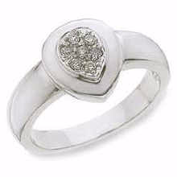

Rings  - The man usually gives the woman a diamond engagement ring when he proposes (asks her to marry him).  - At the wedding, he gives her a gold wedding ring, which is usually just an undecorated band.  - She may give him a wedding ring too. |  | Customs  - It is said to be bad luck for the groom to see the bride in the morning before the wedding.  - According to an old rhyme, the bride should wear:  Something old,  Something new,  Something borrowed, and  Something blue.
 | The well-known music that is played as the bride walks down the aisle is called the “Wedding March”, and was composed in 1843 by Felix Mendelssohn.

